National University of Computer and Emerging Sciences



Task given in Class

22-04-2020

Object Oriented Programming

|  |  |
| --- | --- |
| Name | Muhammad Zain |
| Roll No. | 19F-0228 |
| INSTRUCTOR | Dr Danish |
| Semester | Spring 2020 |

Task 01:

# Source Code:

#include <iostream>

using namespace std;

class Test

{

private:

~Test() {}

};

int main() {

cout << "Just to check program is running or not" << endl;

system("pause>0");

}

# Snip:

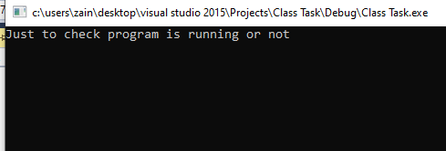

Task 02:

# Source Code:

#include <iostream>

using namespace std;

class Test

{

private:

~Test() {}

};

int main() {

Test obj;

cout << "Just to check program is running or not" << endl;

system("pause>0");

}

# Snip:

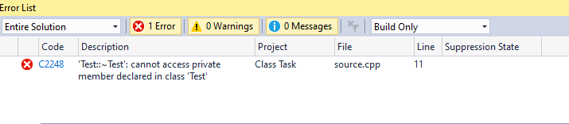

Task 03:

# Source Code:

#include <iostream>

using namespace std;

class Test

{

private:

~Test() {}

};

int main() {

Test *Pointer_obj;

cout << "Just to check program is running or not" << endl;

system("pause>0");

}

# Snip:

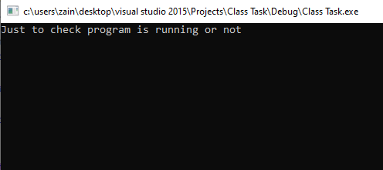

Task 04:

# Source Code:

#include <iostream>

using namespace std;

class Test

{

private:

~Test() {}

};

int main() {

Test* t = new Test;

cout << "Just to check program is running or not" << endl;

system("Pause>0");

}

# Snip:

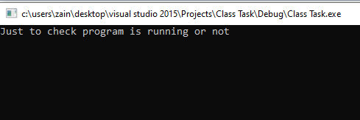

Task 05:

# Source Code:

#include <iostream>

using namespace std;

class Test

{

private:

~Test() {}

};

int main() {

Test* pointerobj = new Test;

delete pointerobj;

cout << "Just to check program is running or not" << endl;

system("Pause>0");

}

# Snip:

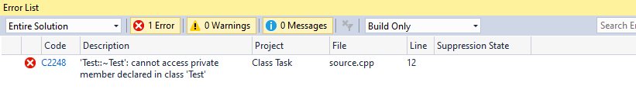

Task 06:

# Source Code:

#include<iostream>

using namespace std;

class Test

{

private:

~Test() {}

friend void d_Test(Test*);

};

void d_Test(Test* pointer) {

delete pointer;

}

int main() {

Test* pointerobj = new Test;

cout << "Just to check program is running or not" << endl;

d_Test(pointerobj);

system("Pause>0");

}

# Snip:

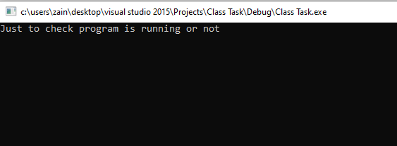

Task 07:

# Source Code:

#include<iostream>

using namespace std;

class Sum_Operator

{

private:

int real, imaginary;

public:

Sum_Operator operator ++()

{

real++;

imaginary++;

return *this;

}

Sum_Operator()

{

cout << "Input the real number "<<endl;

cin >> real;

cout << "Input the imaginary part "<<endl;

cin >> imaginary;

}

void display()

{

cout << "After overloading operator = " << real << " + " << imaginary << " i ";

}

};

int main()

{

Sum_Operator obj_S;

++obj_S;

obj_S.display();

system("pause>0");

}

# Snip:

